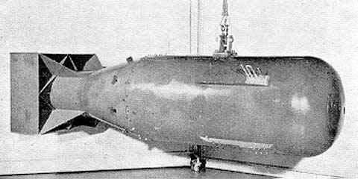

Pros:

1. Japan kept from being invaded by the us.
2. It made peace for the 2 counties.
3. All Japanese people where released from camps in the usa.
4. Saved life’s in American soldiers.

Cons:

1. Killed 10 of thousands of people.
2. Caused mass starvation in japan.
3. Was very expensive for the us.
4. Could have caused another war
5. Could have made japan not like the usa

